**Image Formats**

There are many image formats – bmp, gif, jpg, png and others. What’s the difference between them?

The most basic image format is the **raw bitmap** format. In this format, each pixel on the image is converted to a colour number. Consider a bitmap with three primary colours (say red-green-blue). In this case, you only need 3 bits to represent all the possible combinations of these colours. For example:

100 – red

010 – green

001 – blue

011 – blue-green (aqua)

111 – all three (white)

000 – none (black)

This is a simple 3-bit bitmap scheme. The main drawback is that there is only one shade of red, blue or green. To allow more shades of each colour, most bitmap schemes use at least 8 bits per primary colour. For example, this colour would be very blue with a touch of green and no red:

0000 0000 0011 0010 1111 1100

With 8 bits per colour, this gives 256 shades of red, 256 shades of green and 256 shades of blue giving a total of 224 possible colour combinations. This is called a 24-bit colour scheme. Surprisingly, the eye can detect more colours than this, so it is not perfect, but it’s pretty good.

**Compression Schemes**

A picture contains a lot of pixels, and with 24 bits for each pixel, a picture that is the size of this screen (say 1024 x 768 ) would require:

1024 x 768 x 24 = 18 874 368 bits ... about 18 MB of storage. This is a lot for one picture. We would like to reduce this if we can.

Consider this page: it is mostly white with some black and very little colour. The bitmap for this page would mostly look like this:

1111 1111 1111 1111 1111 1111 1111 1111 1111 1101 1111 1100 1111 1111 1111 1111

and so on, for another 18 874, 340 bits

One compression scheme would be to take repetitive sections and indicate how many repetitions there are. This saves considerable space.

So this:

1111 1111 1111 1111 1111 1111 1111 1111 1111 1111 (five white pixels)

is shortened to this:

1111 1111 0000 0101 - this means “repeat white pixel 5 times”

Another common scheme is to blend neighbouring pixels with similar colours into a single colour, and then use the above scheme. You can notice an image that is compressed in this way if you compare it to the original raw bitmap.

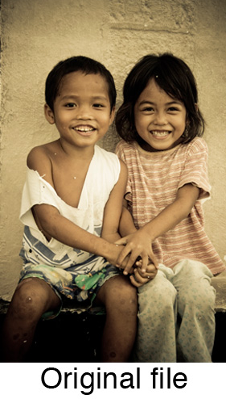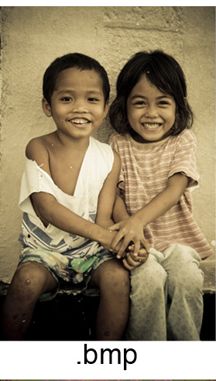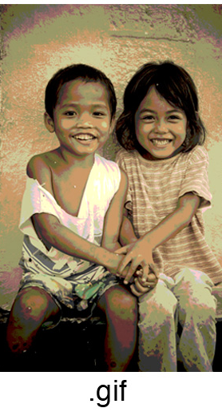

From these examples, you can see that the bitmap (middle) is pretty close, except the colours are not an exact match. The GIF image is highly compressed, making the picture look “patchy” as nearby pixels are all given the same colour value if they are close enough.

Different formats such as **JPEG**, **GIF** and **PNG** have different compression schemes. Each format was invented at different times for different purposes. JPEG is for photography, GIF is for the internet (those annoying emoticons) and PNG is a more modern version of GIF. PNG images can offer an alpha channel for transparency (which we will use later). This “channel” is really an extra 8 bits per pixel to indicate how transparent/opaque an image is.